CS 480

Khoa Le, Thanh Le, Lam Nguyen

Project Progress Report 2

The algorithmic approach we are using is neural network. The algorithm is already implemented in the open source software library TensorFlow. The basic idea is to give the agent a reasonable amount of training data which consists of the states it is evaluating and which actions will be done in that state. By feeding training data and using neural network, the agent will be able to decide the "right" action to take when encounter states which have similar characters in its knowledge base.

We have made great progress in our project, we are able to render the matrix map, movement animation for agent, implement all agents and enemy action functions as well as fix all known bugs. In our design, there is only one part that will take the most time to implement: the knowledge base for machine learning. We have generated 10000 states of the game with different situations for the agent to learn from. Each of those 10000 cases will be evaluated manually by our group member, and every single one of them is going to be given an appropriate action for the agent to take. That is pretty much what our knowledge base for the agent is.

In details, each state of the game is represented by an integer array which contains the following information: position of the agent (x, y co-ordinate), its current direction (0: upward, 1: downward, 2: leftward, 3: rightward), the distance of an enemy, if any, in 4 directions, the distance of an incoming bullet, if any, in 4 directions, available movements (the 4 adjacent cells), and the status of the base. With that information, the agent is going to apply 5 possible actions (move up, down, left, right or shoot encoded as 0, 1, 2, 3, 4) in each state.

We are continue to work on completing all the knowledge data that were generated. After doing so, a real neural network will be implemented using TensorFlow, the external library that we use.

Figure 1: Matrix represents the maze with agents, enemy, and obstacles.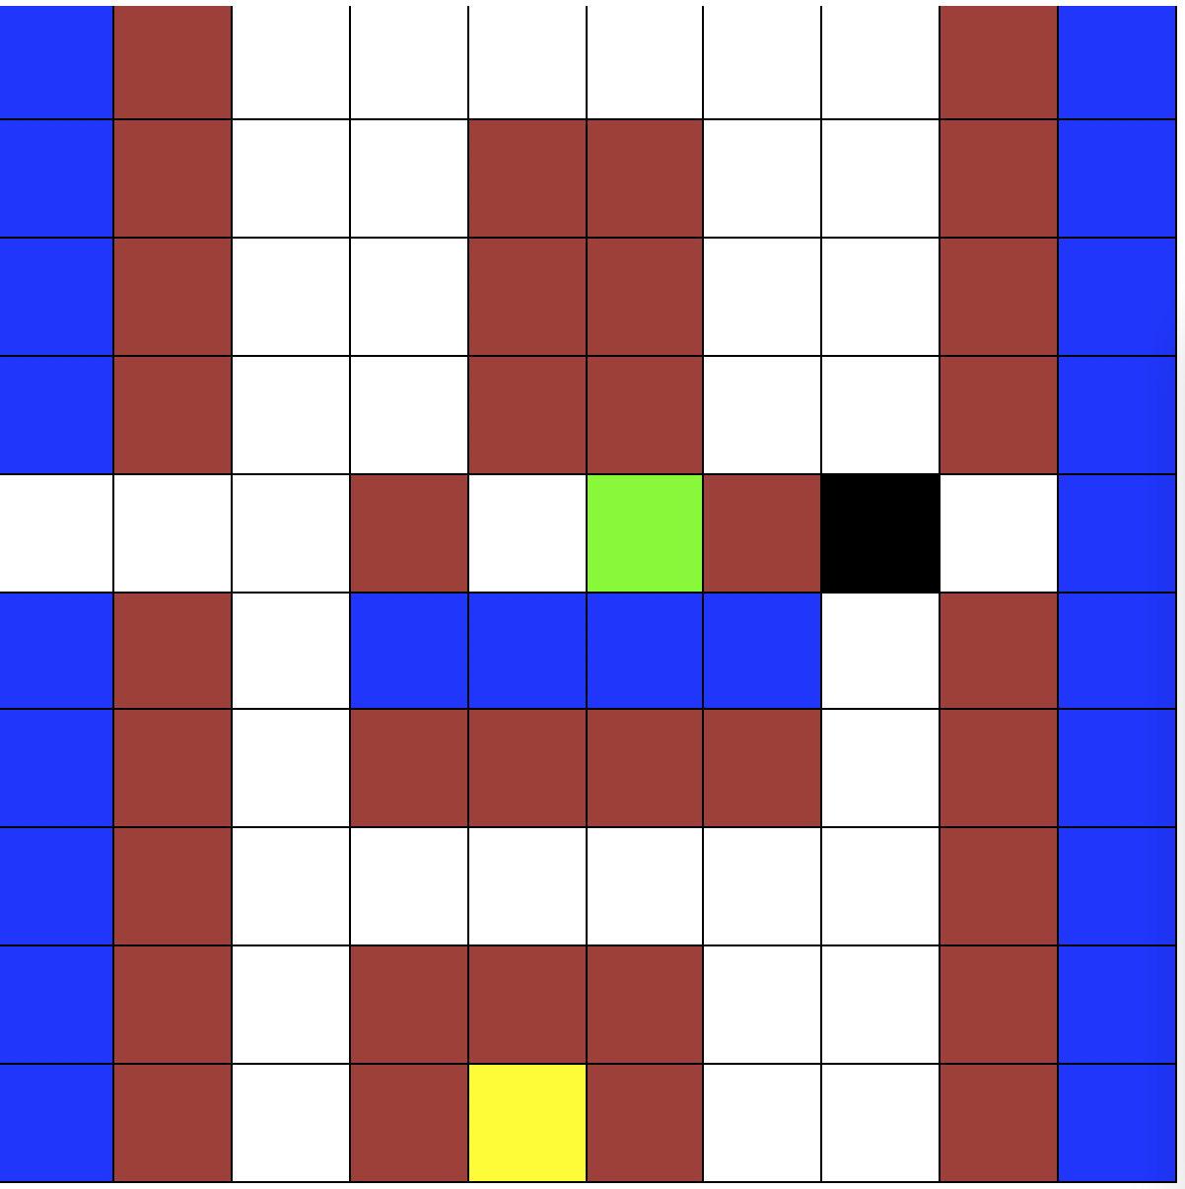

Base

Agent

Enemy

Brick